TECHNICAL SERVICE BULLETIN  Soft Top Roof - Loose Exterior Fabric On Rear Window | 22-2055  21 February 2022
Model:
Ford  2021-2022 Bronco | Soft top roof

Issue: Some 2021-2022 Bronco vehicles equipped with a soft top roof may exhibit loose exterior fabric on the rear window assembly. This may be due to broken D-pillar clips on the rear window. To correct the condition, follow the Service Procedure to replace the D-pillar clips with rivets.
Action: Follow the Service Procedure to repair vehicles that meet all of the following criteria:
• 2021-2022 Bronco
• Equipped with a soft-top roof
• Loose exterior fabric on the rear window due to broken D-pillar clips
Parts
Service Part Number | Quantity | Description | Unit of Issue | Piece Quantity
W790580-S900 | 3 | Rivet | 4 | 10
PM-13-A | As Needed | Motorcraft® Anti-Corrosion Coating
Quantity refers to the amount of the service part number required to repair the vehicle.
Unit of Issue refers to the number of individual pieces included in a service part number package.
Piece Quantity refers to the total number of individual pieces required to repair the vehicle.
As Needed indicates the amount of the part may vary and/or is not a whole number. Parts can be billed out as non-whole numbers, including less than 1.
Warranty Status: Eligible under provisions of New Vehicle Limited Warranty (NVLW)/Service Part Warranty (SPW)/Special Service Part (SSP)/Extended Service Plan (ESP) coverage. Limits/policies/prior approvals are not altered by a TSB. NVLW/SPW/SSP/ESP coverage limits are determined by the identified causal part and verified using the OASIS part coverage tool.
Labor Times
Description | Operation No. | Time
2021-2022 Bronco: Inspect and Install Rivets On Both Side Of the Vehicle Following The Service Procedure (Do Not Use With Any Other Labor Operations) | 222055A | 1.1 Hrs.
Repair/Claim Coding
Causal Part: | 7842006
Condition Code: | 01

Service Procedure
1. Visually inspect the 5 clips that run vertically along each D-pillar on the rear window (Figure 1)
Figure 1 - Right D-pillar shown, left side similar
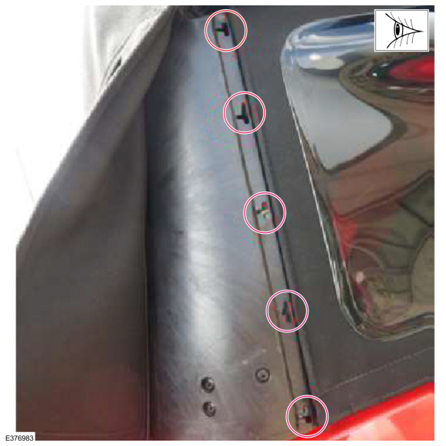
2. Are any of these clips broken causing the rear window fabric to become loose?
(1). Yes - proceed to Step 3.
(2). No - this article does not apply.
3. Remove both rear quarter windows and place them aside on a smooth clean surface. Refer to workshop manual (WSM), Section 501-18A.
4. Remove the rear window. Refer to WSM, Section 501-18A.
5. Place the rear window down on a flat clean worksurface, interior side up.
NOTE: This procedure will update both D-pillars. Do not attempt to work on both D-pillars at the same time. Follow the steps to update one side, then continue to the other side when directed to do so.
6. Using an interior trim tool, remove the plastic channel from the D-pillar. (Figure 2)
Figure 2
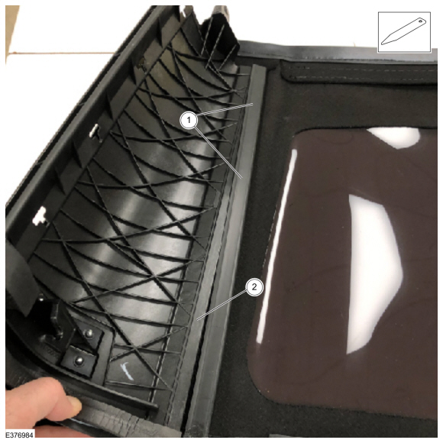
7. Center the plastic strip on the D-pillar with the plastic strip on the rear window so they sit directly on top of each other. (Figure 3)
Figure 3
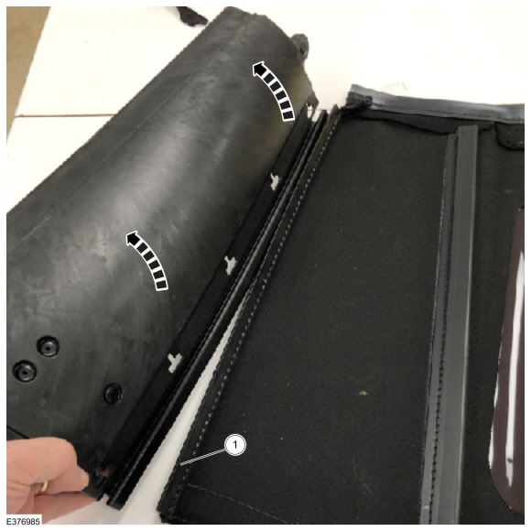
8. Use 2 small clamps to hold both pieces together, one at each end. (Figure 4)
NOTE: T-clips may be trimmed/removed as needed to achieve flushness and the proper gap between the window and the D-pillar. T-clip retention will no longer be required once the rivets are installed.
Figure 4
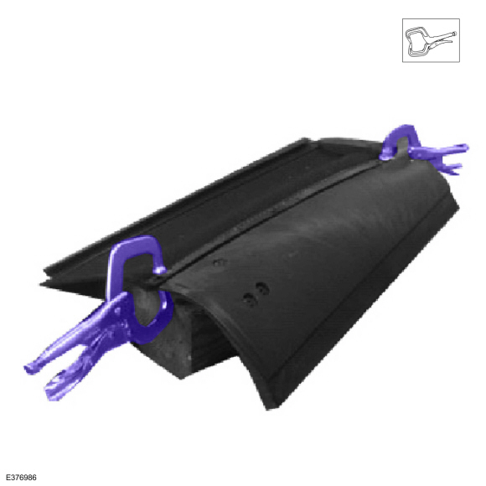
9. Measure and mark all 5 locations on the plastic strip to be drilled following the sequence below. (Figure 5)
Figure 5
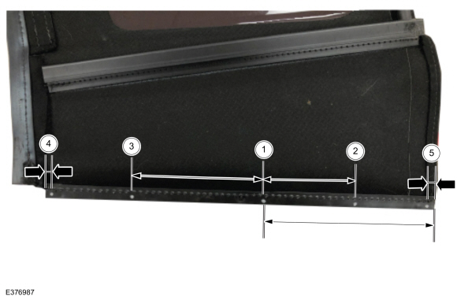
Item | Description
1 | 185 mm up from the bottom edge
2 | 100 mm down from Location 1
3 | 140 mm up from Location 1
4 | 6 mm down from the upper edge
5 | 6 mm up from the bottom edge
10. Rotate the clamped D-pillar and plastic strip assembly so that the round side is facing up. Obtain an even 5 mm gap between the D-pillar and the rear window plastic strip. Loosen the clamps as needed to allow for adjustments. Reapply both clamps once the proper gap is achieved. (Figure 6)
Figure 6
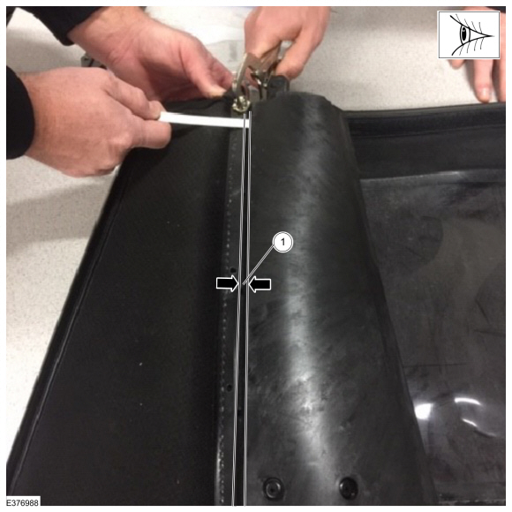
11. Drill the holes using a 5 mm drill bit. Starting at the bottom and working toward the top. Do not drill into the surrounding stitches. Remove the clamps once all 5 holes have been drilled. (Figure 7)
Figure 7
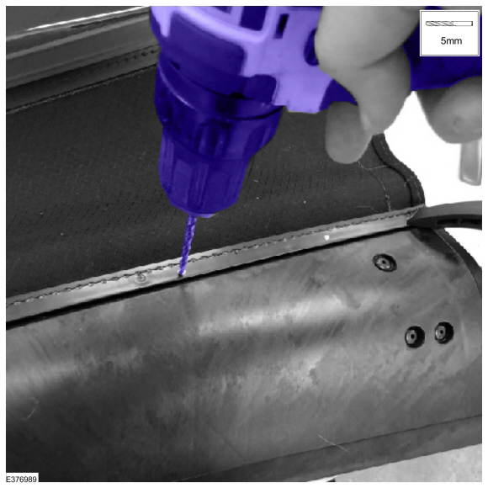
12. Install all 5 rivets, one at a time, using one 5 mm flat washer as support around the back of each rivet. During this process, maintain the 5 mm gap as mentioned in Step 10. (Figure 8)
NOTE: The 5 mm gap between the D-pillar and the rear window plastic strip is critical. If this gap is too large or small, the rear window to rear quarter window fitment and appearance will be jeopardized.
Figure 8
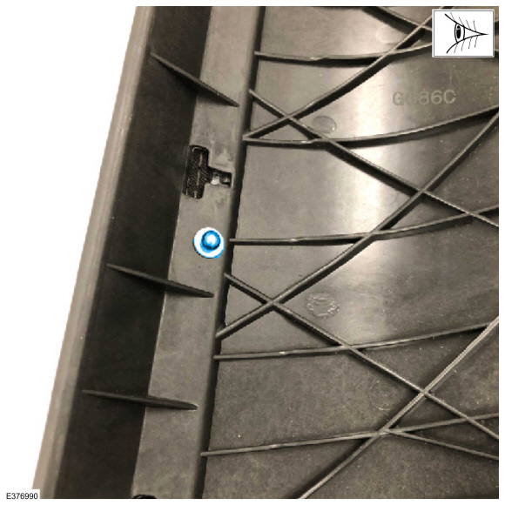
13. Reinstall the plastic channel back onto the D-pillar using an interior trim tool. (Figure 2)
14. Inspect the outer edge between the D-pillar and the rear window. The appearance should be consistent across the entire edge and look consistent with the edge on the opposite D-pillar to rear window edge. (Figure 9)
Figure 9
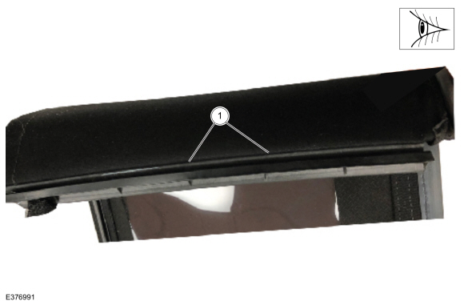
15. Carefully clean the rear window assembly removing all metal shavings.
16. Apply Motorcraft® Anti-Corrosion Coating to all exposed metal rivets and flat washers that were installed during Step 12. No bare metal should be exposed. (Figure 10)
Figure 10
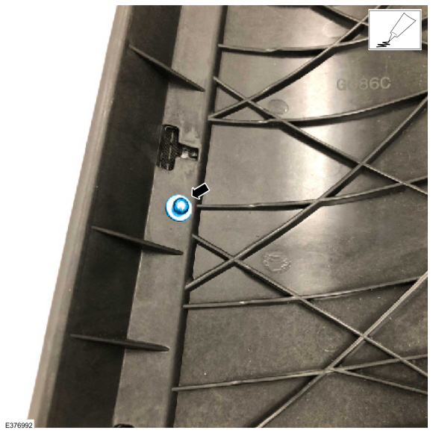
17. Install the rear quarter windows and rear window back on to the vehicle. Compare the appearance of the rear quarter windows and rear window fitment. Using the unworked/previously worked D-pillar as a baseline, their appearance should be identical.
NOTE: Failing to maintain the 5 mm gap may cause fitment issues. Too large of a gap will cause the rear quarter window to fit too loosely in the rear window channel. Too small of a gap will cause the rear quarter window to not sit completely flush in the rear window channel.
18. Once D-pillar fitment has been verified, repeat Steps 3-17 for the other side.

