GENERAL SERVICE BULLETIN  Bronco Roof Concern Analysis | 22-7120  27 September 2022
Summary
This article is designed to provide examples of Bronco soft and hard top damage to assist in determining if the condition is warrantable or non-warrantable.
Service Information
Hard top cleaning and care
• Use a sponge to remove dust and lose dirt on the hard top surfaces.
• Wipe the surface with a soft, damp cloth with a mild soap and water solution. Dry the area with a clean, soft cloth.
• Use of unapproved chemicals, solvents, cleaning products, or use of abrasive cleaners, may damage the hard top surfaces.
• Information on approved cleaning and care products can be found in the Owner’s Manual (Vehicle Care section).
• Do not use a cleaner containing alcohol or any type of solvent on the hard top surface.
• Do not use power tools, paste wax or polish on the hard top surface.
• Test any conditioner or spray wax on an inconspicuous area before applying broadly.
• Make sure the surface of the hard top is dry before applying a small amount of conditioner or spray wax.
Soft top cleaning and care
• Remove lint with a lint roller or a vacuum with a soft bristle brush.
• Wash with an approved high quality convertible top cleaner and protectant.
• Do not use stiff bristle brushes, abrasive materials, or household cleaning products.
• High pressure water may cause water leaks and possible seal damage to the convertible top.
• Use only a microfiber cloth, cold or lukewarm water, and a mild soap and water solution to clean the soft top windows by cleaning in a circular motion.
• Rinse thoroughly with cold water then wipe with a soft, damp cloth.
• Use a small amount of soft top window cleaner or equivalent to remove fine scratches as this will improve the visibility and provide UV protection to help prevent yellowing.
• Information on approved cleaning and care products can be found in the Owner’s Manual (Vehicle Care section).
• Test any cleaner on an inconspicuous are before applying broadly.
• Do not use hot water or anything stronger than mild soap on the soft top window.
• Do not use solvents such as alcohol or harsh cleaning agents on the soft top.
• Do not use a scraper or de-icing chemicals to remove frost, snow, or ice. Use warm water only.
• Do not apply stickers, gummed labels, or any tape on the soft top window surface.
Non-warrantable conditions
• Cracks
• Soiling
• Pry marks
• Damage, burns, soil marks, cuts, scratches, scuffs, tears, or punctures
• Damage/surface appearance issues due to chemicals, solvents, or use of non-Ford approved cleaners and/or abrasives
• Locator pin and/or surface cracked/damaged on rear cap
• Tears or scuffs on the canopy
• Soft top frame damage
• Rear/side window scratches or distortions
• Window buckles damaged
Hard Top Conditions
Surface appearance issues caused by use of unapproved chemicals and/or abrasives (Non-warrantable)
• Splotchy or cracking appearance over a large area of the hard top panels
• Discoloration around the affected area (Figure 1-4)
Figure 1
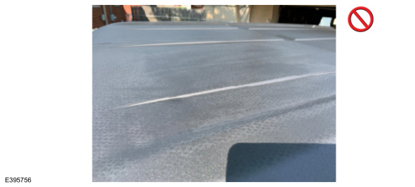
Figure 2
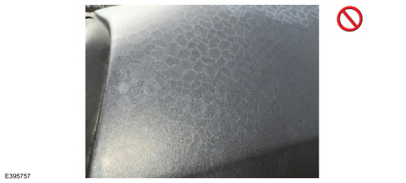
Figure 3
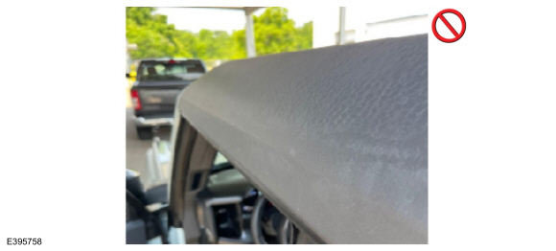
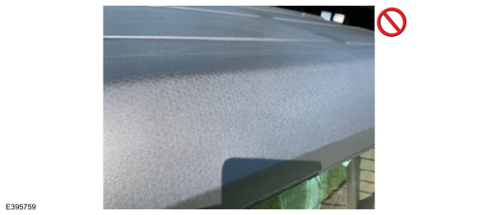
Honeycomb pattern (Warrantable)
• Light honeycomb pattern showing without additional discoloration in the area of concern (Figure 5-6)
Figure 5
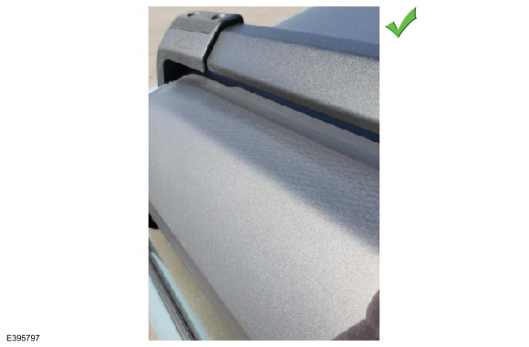
Figure 6
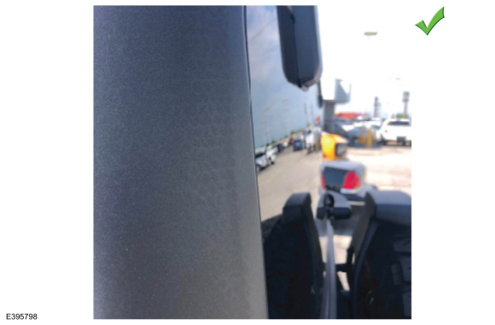
Locator pin and surface cracked/damaged on the rear cap (Non-warrantable)
• Damage to the pin or to the surrounding surface
• Can be damaged if dropped on the floor or on a hard surface after hard top removal (Figure 7-9)
Figure 7
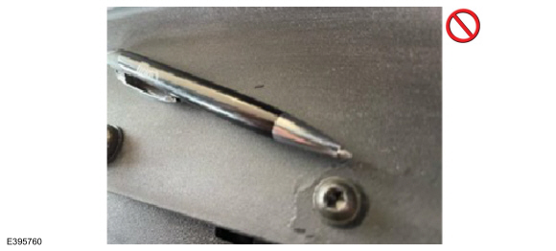
Figure 8
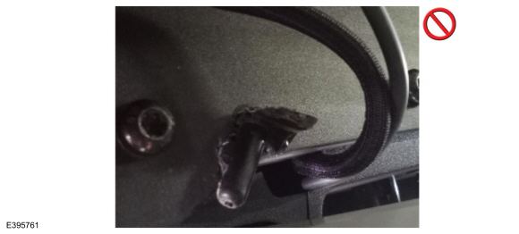
Figure 9
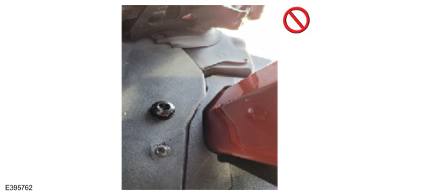
Cracks and scratches (Non-warrantable) (Figure 10-14)
Figure 10
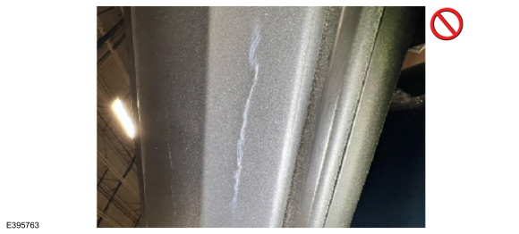
Figure 11
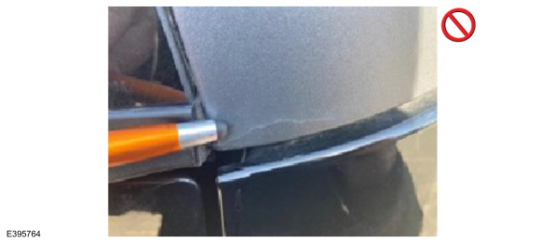
Figure 12
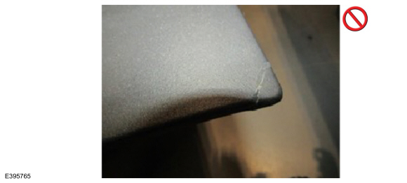
Figure 13
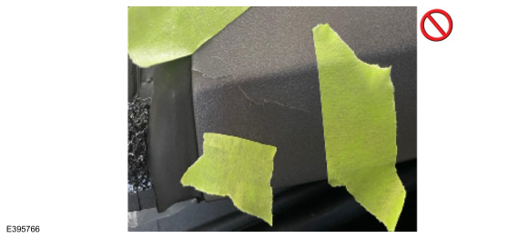
Figure 14
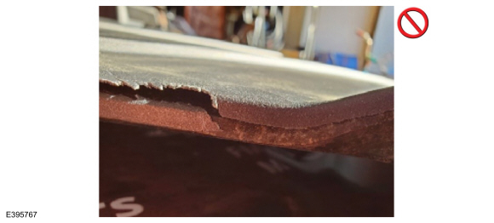
Soft Top Conditions
Damage on the front header corners (Non-warrantable)
• Cracks on the front header and/or damage to the latches
• Indicates external impact (Figure 15-16)
Figure 15
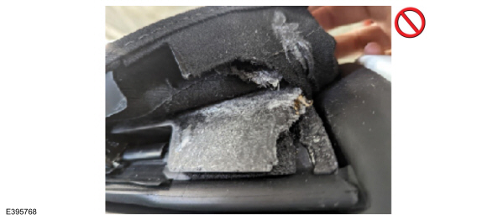
Figure 16
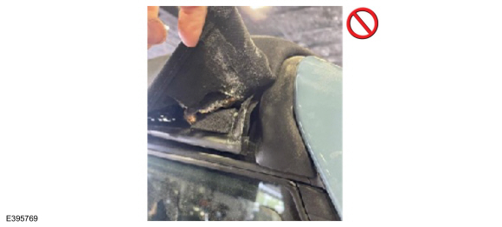
Tears/scuffs/abrasions on the canopy (Non-warrantable)
• Commonly seen on the front corners
• Indicates impact (Figure 17-19)
Figure 17
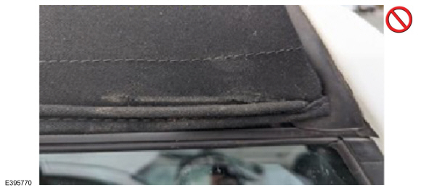
Figure 18
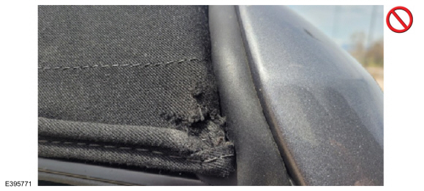
Figure 19
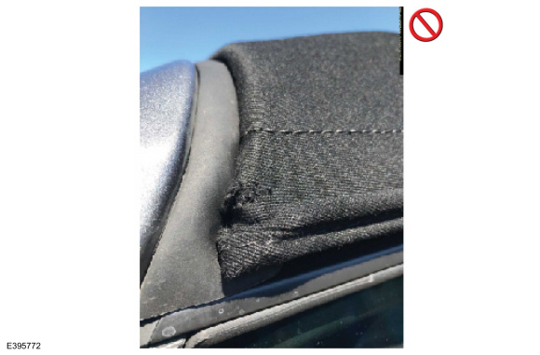
Soft top frame bent (Non-warrantable)
• Bent soft top frame can only be caused by an external force (example: driving into a garage with the soft top in the open throw-back position) (Figure 20-21)
Figure 20
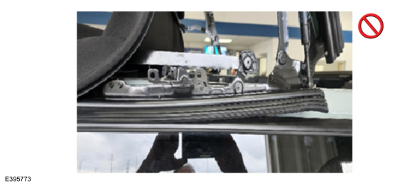
Figure 21
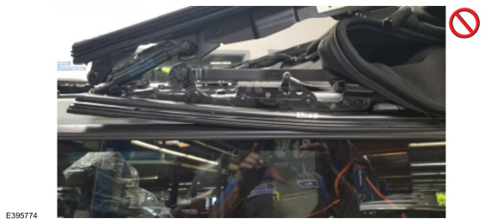
Rear/side window scratches or distortions (Non-warrantable) (Figure 22-24)
Figure 22
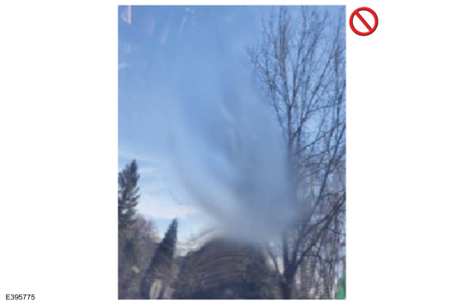
Figure 23
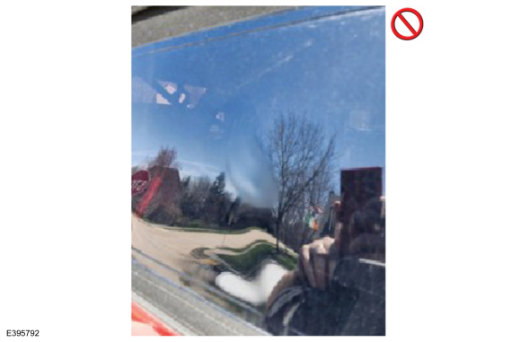
Figure 24
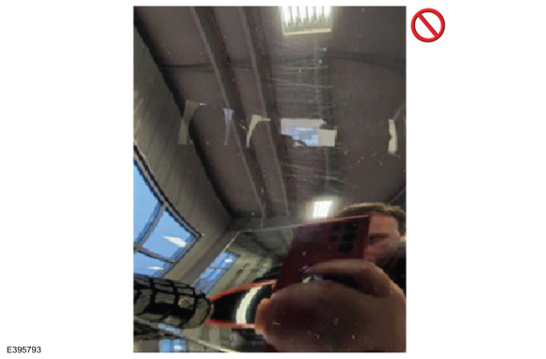
Rear/side window buckles damaged (Non-warrantable) (Figure 25-27)
Figure 25
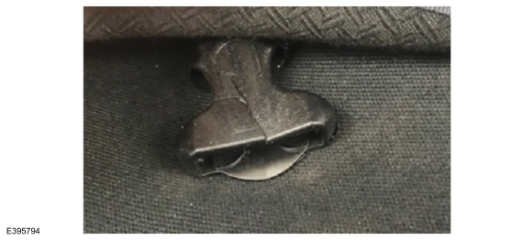
Figure 26
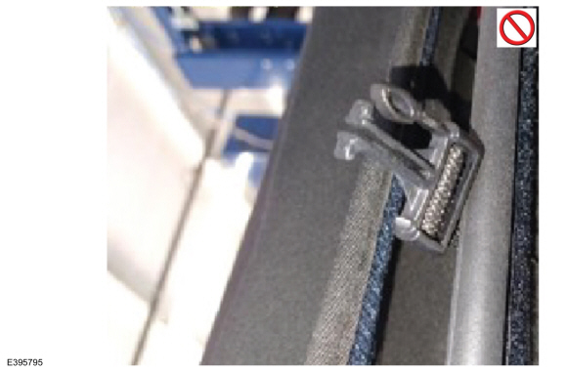
Figure 27
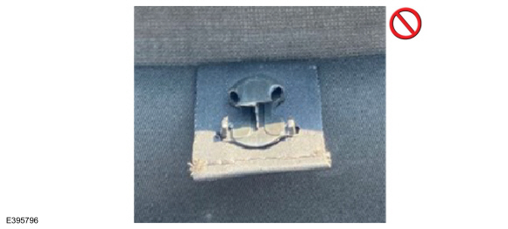
The soft top window buckles (male and female) are available in the parts catalog as an end item. Buckle failure does not require replacement of the soft top window or soft top material.

