- Remove the factory mirror.
Disconnect the electrical Connector If Equipped.
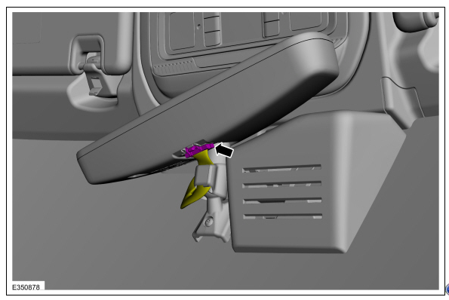
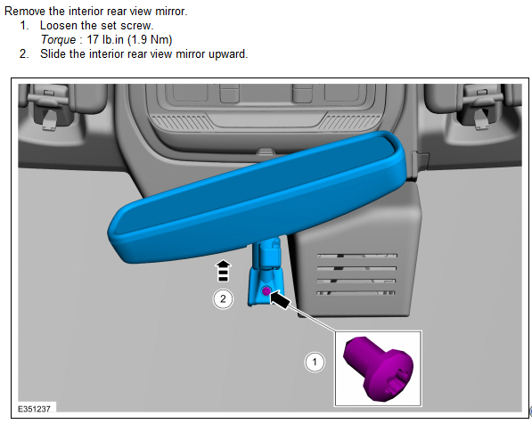
Install the Brandmotion Mirror Torque : 17 Lb.in (1.9Nm)
- Remove the A-pillar trim. Drivers and Passenger side.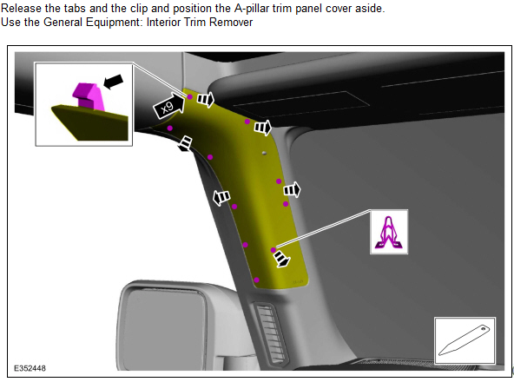
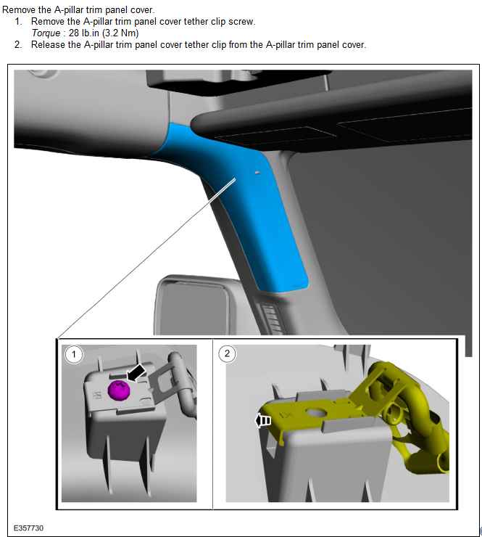

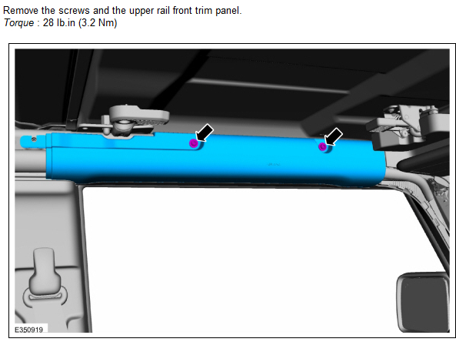
      - Loosen Bolt. Note the bolt is captured to the bracket and will not come out. Torque : 80 lb.in (9 Nm)
      - Lift upward and outward on the side curtain airbag tether clip and position aside.
      - Release the side curtain airbag pin-type retainer.
      - Remove the retaining bolt for the side curtain airbag bracket to allow the air bag to be moved out of the way.
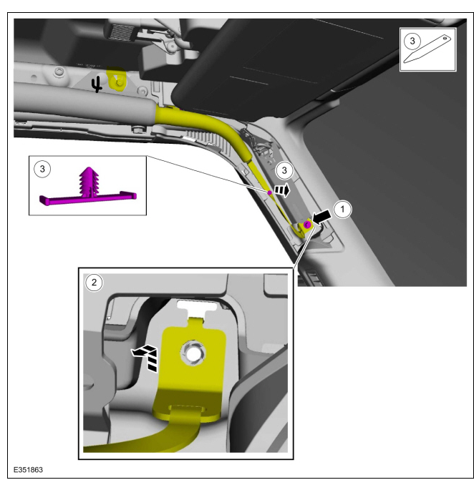

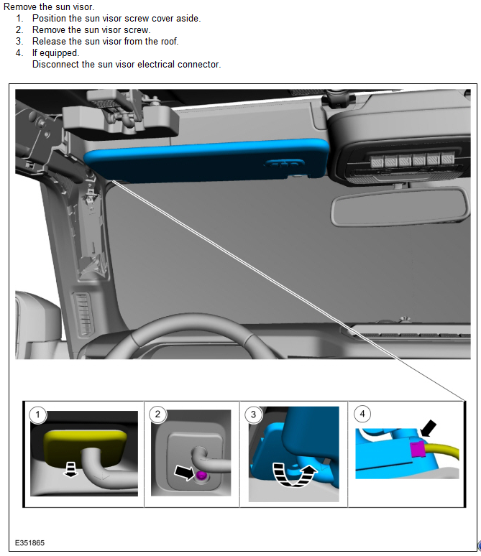

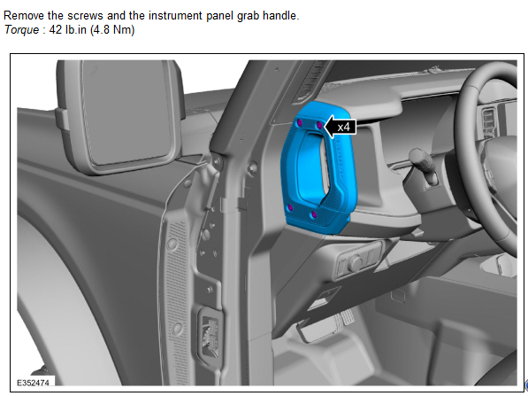

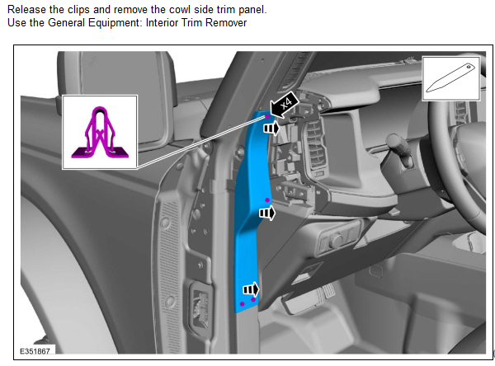

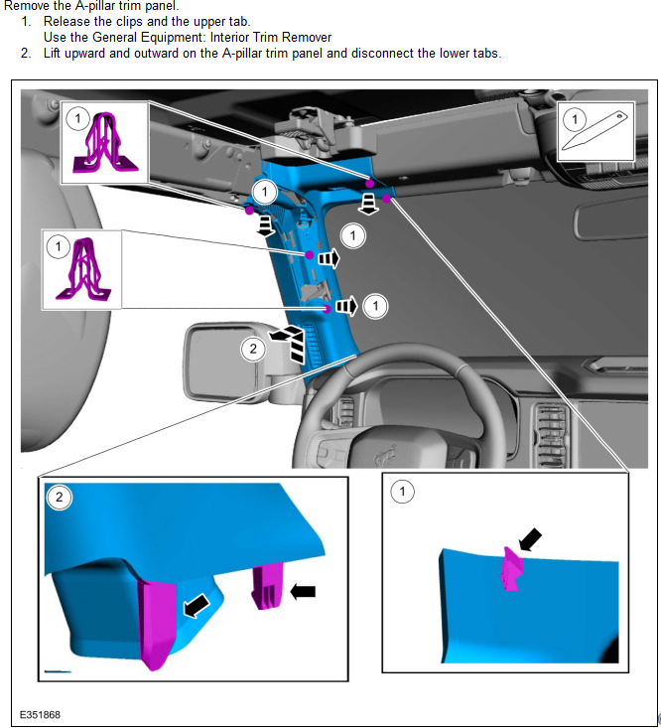
2)Remove the Header Trim Panel

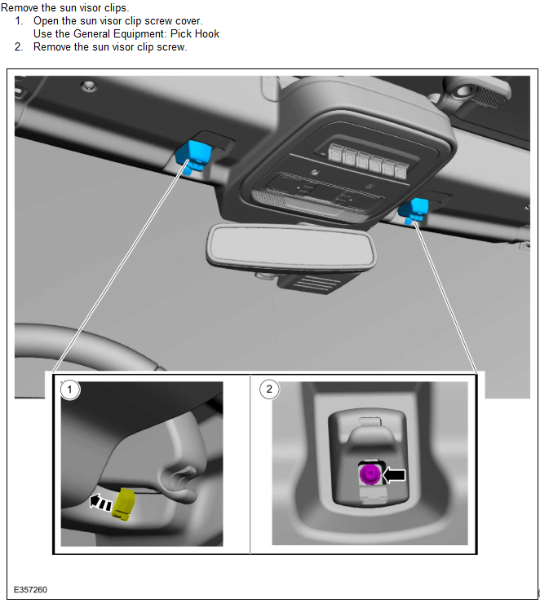
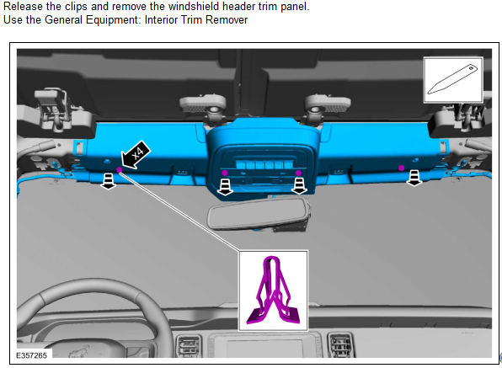
- Begin by routing the pin connectors of the harness up the driver A Pillar toward the mounting point for the sun visor.
Continue feeding the 2 pin locations toward the center of the headliner.
Secure the mirror harness to the existing harness.
After connecting both harness and the mirror loosely attach the header Trim in place.
- Route the Rear Camera harness down the passenger A-pillar to the rear cargo door.
Remove the Passenger front door scuff plate.
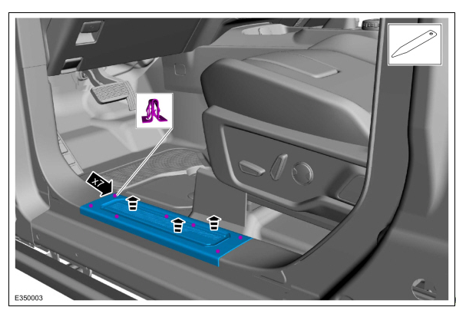
Remove the Passenger front Kick Panel
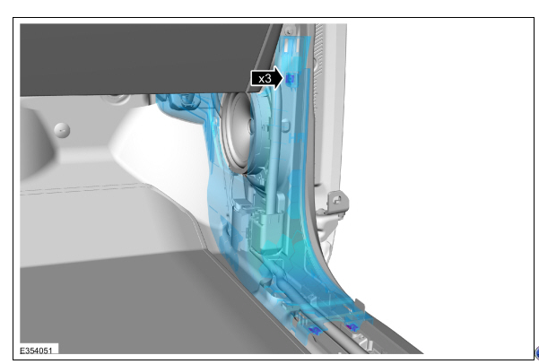
Remove the Rear passenger Door Scuff plate panel.
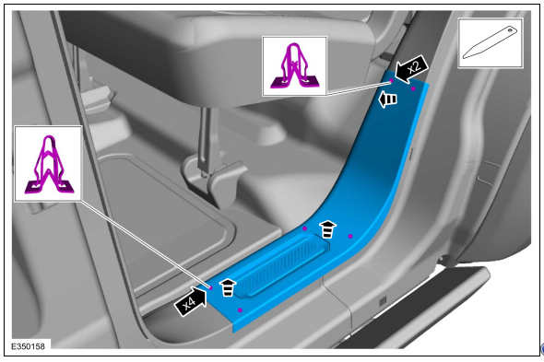
Remove the Load space scuff plate trim panel.
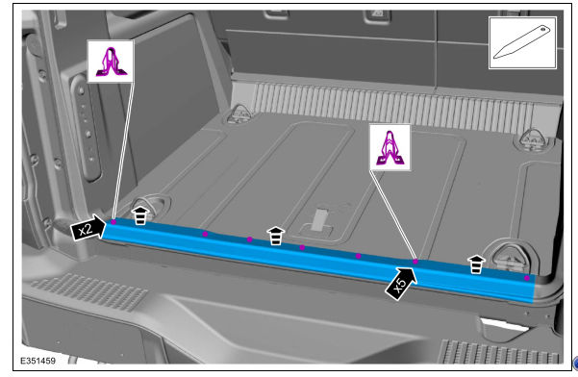
Loosen the Passenger side load space trim panel at the top and back but do not remove.
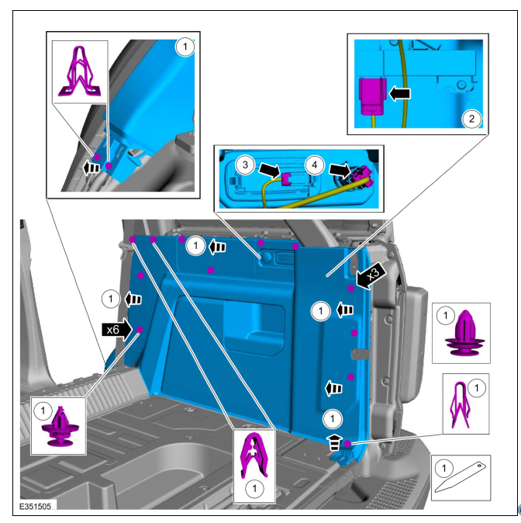
- Remove the upper lift gate trim panel.
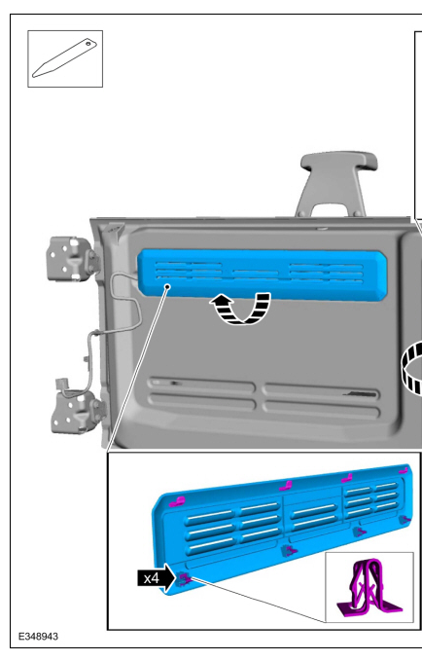
- Route the harness along the factory harness. (optionally you can remote the tape from the ends of the harness shroud and route the cable through it and retape the ends once your have the harness connected to the rear camera.)
- Remove the spare tire.
- Slide the camera bracket on the top two studs.
- Temporarily place the spare tire back on the studs to check and confirm proper camera placement with respect to the spokes of the rim.
- One lock washer will be placed on each of the studs that the bracket is hanging on. The third lock washer will lock the nylon washer in its place on the very bottom stud. This is needed to make the wheel sit evenly on the carrier.
- Temporarily install the Spare Tire to verify the camera is in the correct position then remove the Spare tire
Wait to install the spare tire back on the carrier. This will give you more room to work through the steps in the next section.
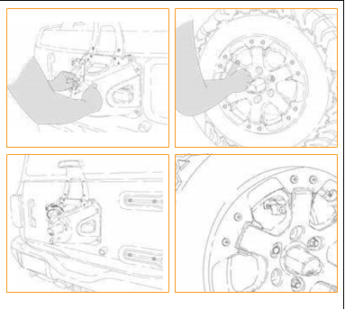
- Feed the chassis harness connector through the marked hole, and out the rear vent of the tailgate.
- Place the provided strip of heat-shrink on the camera harness, then connect the camera to the harness via the top hole in the tire carrier.
- Turn the vehicle on and check the rear vision video connection.
- Use a heat gun or a lighter to seal the heat shrink. Heat shrink should overlap both sides of the connections.
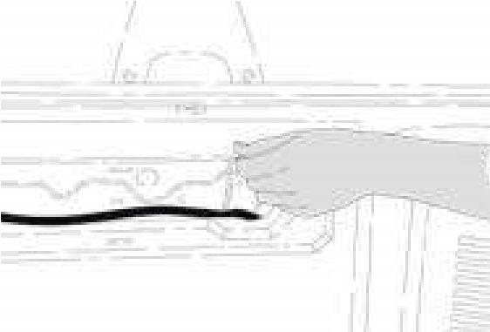
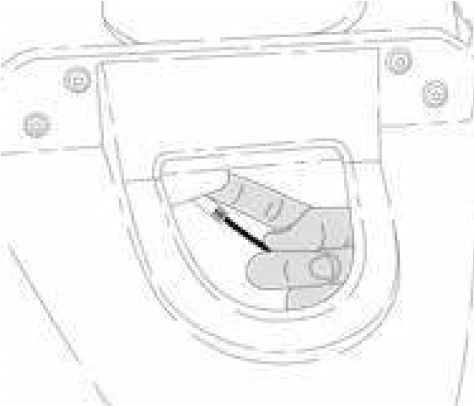

- Reinstall the spare tire.
- 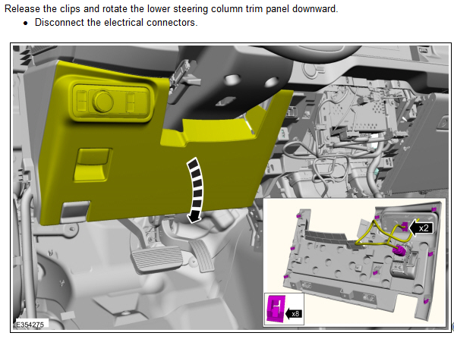

- Attach the mirror harness to the fuse panel using the supplied add a fuse connectors.
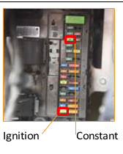
- Power on the vehicle to test the mirror and camera.
- Reinstall all removed panels.

