TECHNICAL SERVICE BULLETIN  Whistle Noise At Lower Left Windshield Area - Built On Or Before 28-Apr-2022 | 22-2306  01 August 2022
Model:
Ford  2022 Bronco | Built on or before 28-Apr-2022

Issue: Some 2022 Bronco vehicles may exhibit a whistle noise below the lower left windshield area at the bottom of the A-pillar. This may be due to a missed body sealer application at the factory. To correct this condition, follow the Service Procedure to reseal the affected body seam.
Action: Follow the Service Procedure to correct the condition on vehicles that meet all of the following criteria:
• 2022 Bronco
• Built on or before 28-Apr-2022
• Whistle noise from the lower left windshield area
Parts
Service Part Number | Quantity | Description
Obtain Locally | As Needed | 3M® 2 Inch Wide Masking Tape Or Equivalent
Obtain Locally | As Needed | Butyl - 3M® 08612 Windo Weld Round Ribbon Sealer Or Equivalent
As Needed indicates the amount of the part may vary and/or is not a whole number. Parts can be billed out as non-whole numbers, including less than 1.
Warranty Status: Eligible under provisions of New Vehicle Limited Warranty (NVLW)/Service Part Warranty (SPW)/Special Service Part (SSP)/Extended Service Plan (ESP) coverage. Limits/policies/prior approvals are not altered by a TSB. NVLW/SPW/SSP/ESP coverage limits are determined by the identified causal part and verified using the OASIS part coverage tool.
Labor Times
Description | Operation No. | Time
2022 Bronco: Install Tape, Road Test (Pass) Inspect Gap And Apply Butyl Sealer If Necessary (Do Not Use With Any Other Labor Operations) | 222306A | 1.2 Hrs.
Repair/Claim Coding
Causal Part: | 5802012
Condition Code: | 68

Service Procedure
1. Tape off the left side of the cowl panel and drive the vehicle above 50 mph (80 Km/h). Did taping off the cowl resolve the whistle noise? (Figure 1)
Figure 1
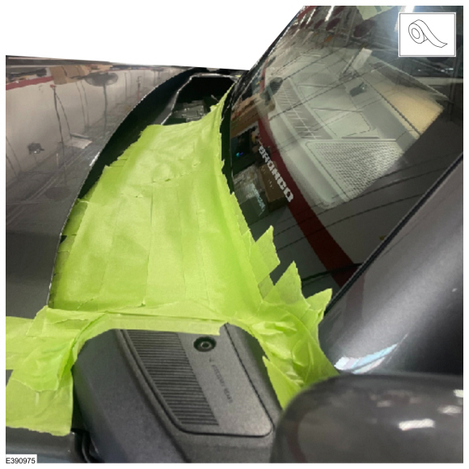
(1). Yes - proceed to Step 2.
(2). No - this article does not apply. Refer to Workshop Manual (WSM), Section 100-04.
2. Remove the left A-pillar trim. Refer to WSM, Section 501-05.
3. Visually inspect for a gap in the sheet metal at the bottom of the A-pillar where it joins the rear engine compartment wall. Is a gap present? (Figure 2)
Figure 2
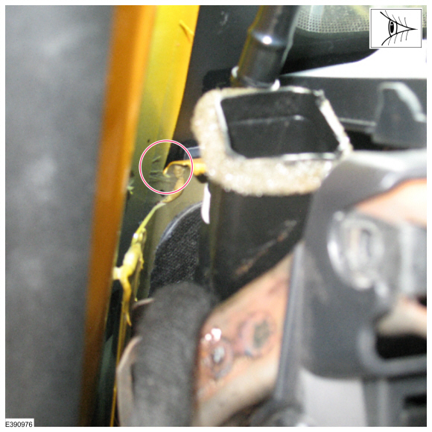
(1). Yes - proceed to Step 4.
(2). No - this article does not apply.
4. Apply a liberal amount of butyl to fill the gap between the two metal panels and eliminate the air entry.
5. To assemble, reverse the removal procedure.

